Victorian 7 – 10 Country Competition Meet 2017
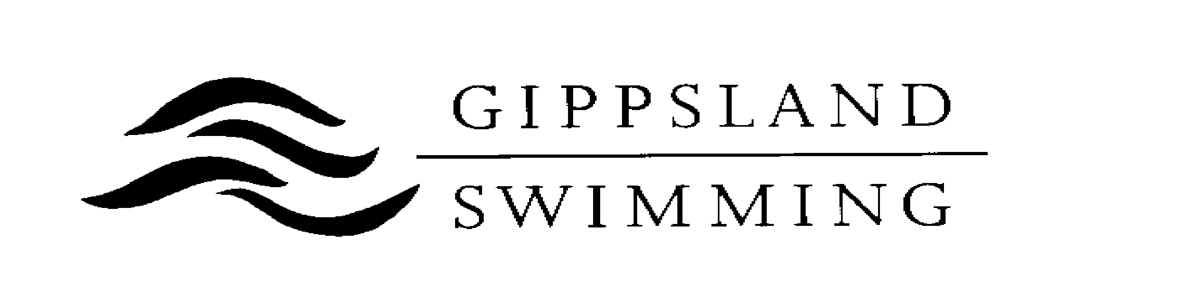
Availability Form

Are you available for the following team if selected?

Victorian 7 – 10 Country Competition Meet (only swimmers aged 7 to 10 years as at 4/11/2017)

Saturday, 4th November 2017 at MSAC. YES / NO (please circle)
(Please note that the swimmer may only be selected for one event or relay)
Applications Close: Sunday 15th October 2017

Name: __________________________________ Club: ______________________________

Address: _____________________________________________________________________

Date of Birth: _____________________ Age (as at 4/11/2017) ______________________

Email Address: ________________________________________________________________

Phone Number: ______________________ Male / Female (please circle)

If selected, Gippsland Swimming will provide swimmers with a Polo Shirt and Cap to wear on the day. Please nominate size of Polo Shirt required.

Polo Shirt Size
Children’s Size | Tick | Adult Size | Tick
8 |  | S
10 |  | M
12 |  | L
14 |  | XL
16 |  | XXL

Parent / Guardian Signature: ______________________________________________

Please return Availability Form to:

Renee Cargill

Team Selection Secretary
Gippsland Swimming Inc

C/O PO Box 68
Traralgon 3844

Or via email: regcargs@wideband.net.au
Enquiries: Phone (m) 0438 762 916

