Victorian Country Junior District Competition 2026
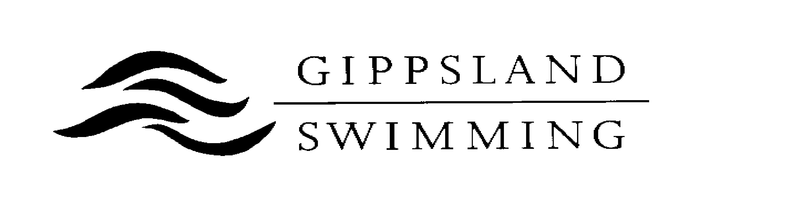
Availability Form

Are you available for the following team if selected?

Victorian 8 – 11 Junior District Competition (only swimmers aged 8 to 11 years as at 21/11/2026)

Saturday, 21st November 2026 at MSAC. YES / NO (please circle)
Applications Close: Sunday 1st November 2026.

Name: __________________________________ Club: ______________________________

Address: _____________________________________________________________________

Date of Birth: _____________________ Age (as at 21/11/2026) ______________________

Email Address: ________________________________________________________________

Phone Number: ______________________ Male / Female (please circle)

If selected, Gippsland Swimming will provide swimmers with a Polo Shirt and Cap to wear on the day. If you would like to purchase the polo top, please deposit $30.00 into bank account below with child’s surname as a reference. Bank Account Details:
Account Name: Gippsland Swimming
BSB: 063 532
Account No: 10081893

Please nominate size of Polo Shirt required.

Polo Shirt Size
Children’s Size | Tick | Adult Size | Tick
8 |  | S
10 |  | M
12 |  | L
14 |  | XL
16 |  | XXL

Parent / Guardian Signature: ______________________________________________

Please return Availability Form to:

Brooke Said

Team Selection Secretary Gippsland Swimming Inc via email: teams@gippslandswimming.org.au
Contact: Phone (m) 0438 455 343

